**COS10026 : lab07 Task 4**

SELECT * FROM cars;  
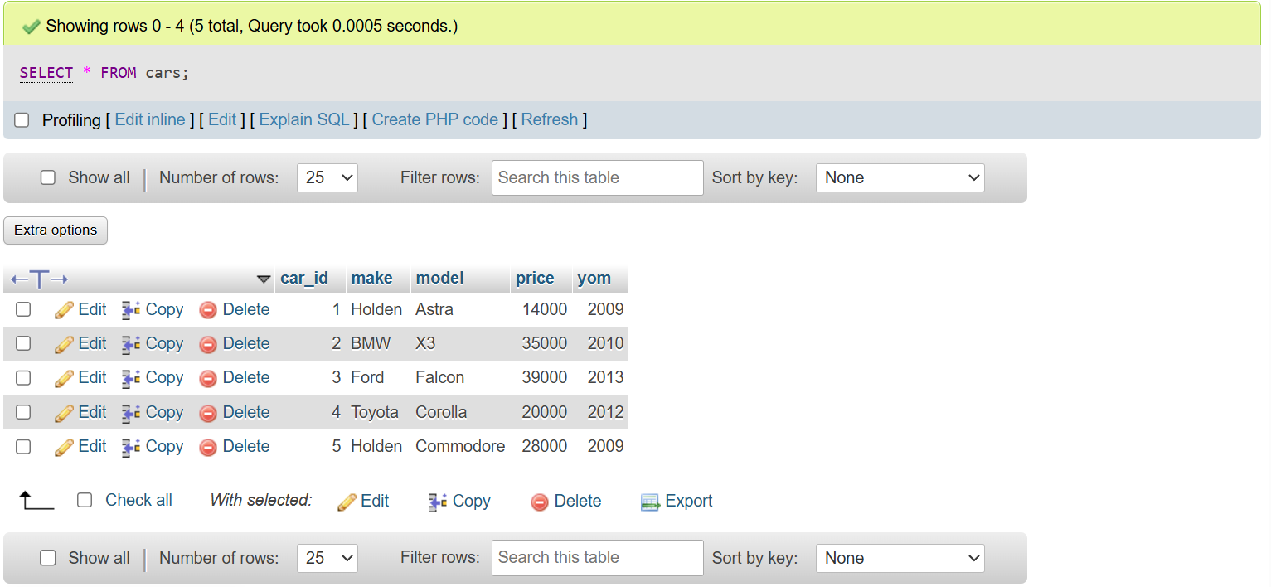

SELECT make, model, price FROM cars ORDER BY make, model; // ORDERBY means sort

SELECT make, model FROM cars WHERE price >= 20000;

SELECT make, AVG(price) FROM cars GROUP BY make;

SELECT make, model FROM cars WHERE price < 15000 AND price > 10000;

